

**FPT ACADEMY INTERNATIONAL**

**FPT – APTECH COMPUTER EDUCATION**

**USER GUIDE NEWSPAER WEBSITE**

**I. System Requirement**

|  |  |  |
| --- | --- | --- |
| **No** | **Software** | **Description** |
| **1** | **Operating system** | **Windows 7 or higher** |
| **2** | **Hardware** | **Intel Pentium 4 processor or higher**  **512 Megabytes of RAM or higher** |
| **3** | **Software** | **Visual Studio Code, Dreamweaver** |
| **4** | **Web browser** | **Internet Explorer 11 , Chrome, Firefox** |

1. **Introduction and website installation**

- This document is created to guide users use the website –Newspaper. It is advisable that users should read this document before starting to use this website in reality.

- To run *Prime Fitness* website, users need to do the following steps:

* + - 1. Download the file rar *Newspaperweb–DNBC NEWS by Group 3 (FPT Aptech HCM)* via this link:
      2. Extract the file rar: *Newspaperweb –DNBC NEWS by Group 3 (FPT Aptech HCM)*

1. Open the folder *Newspaperweb*
2. Open *index.html* file to start the website. Look at figure 1 for illustration
3. 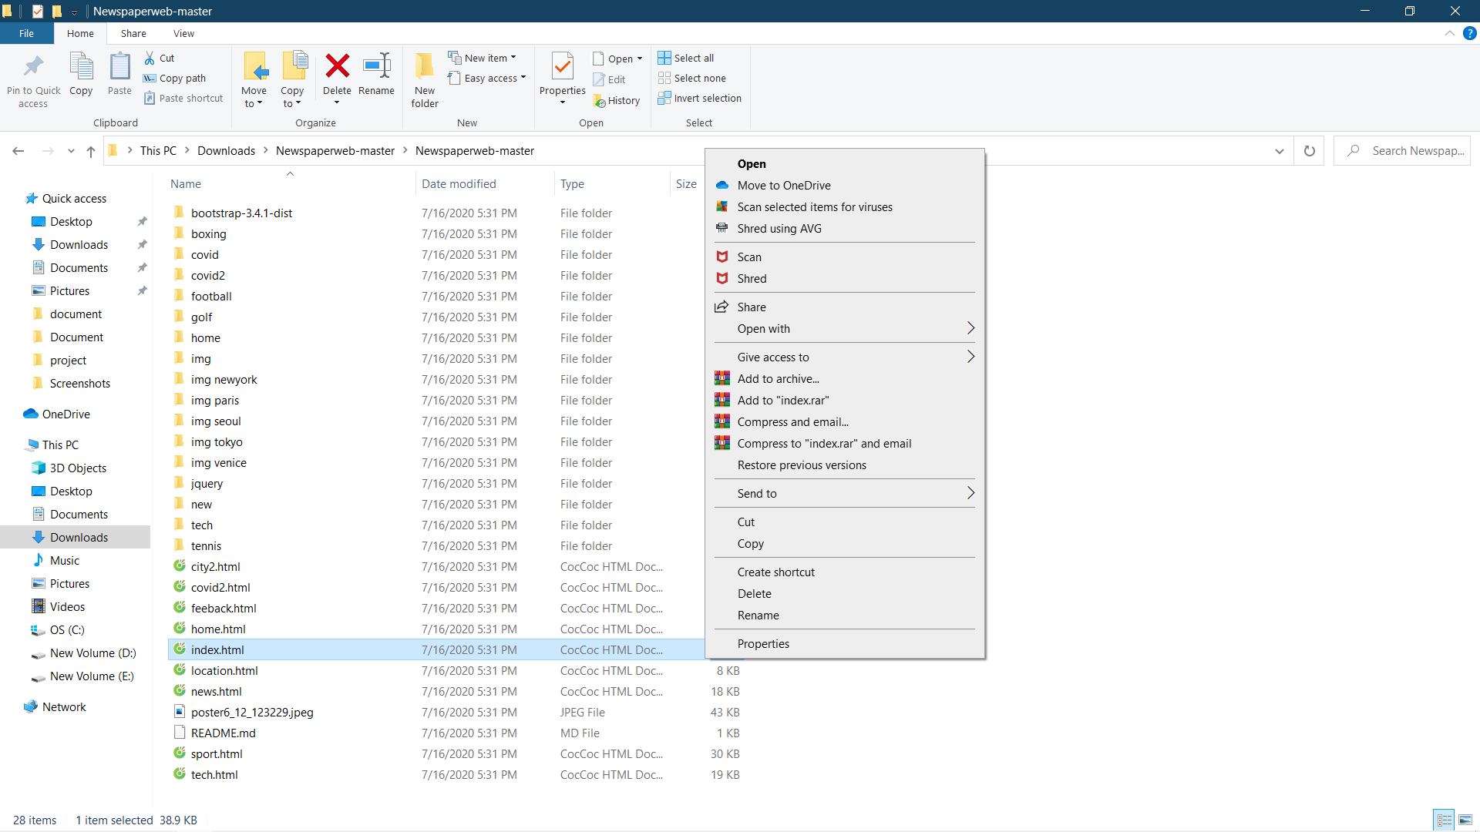
4. If done successfully, users will see the Homepage like figure 2 below
5. 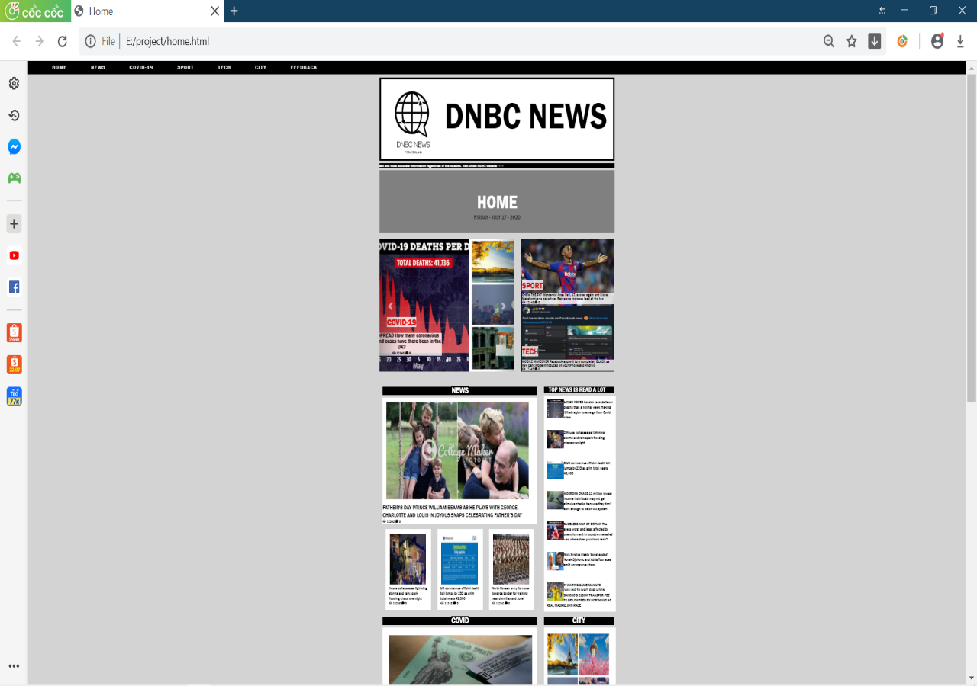

*Figure 2*

1. **Homepage**

-This page shows a summary of all content about the Covid pandemic news, breaking news, sports news, technology news and a summary of the most read articles.

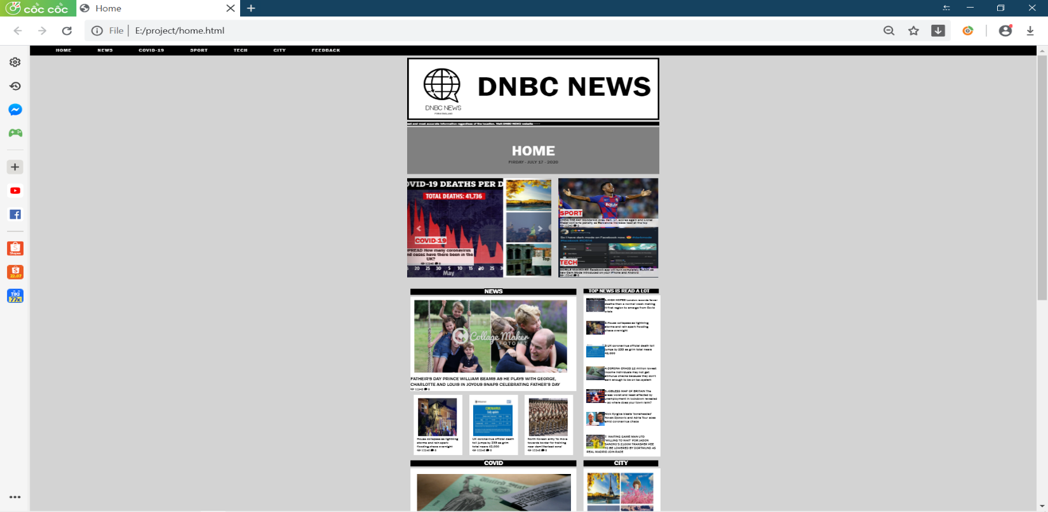

1. **News page**

- This page displays updates on news about life news.

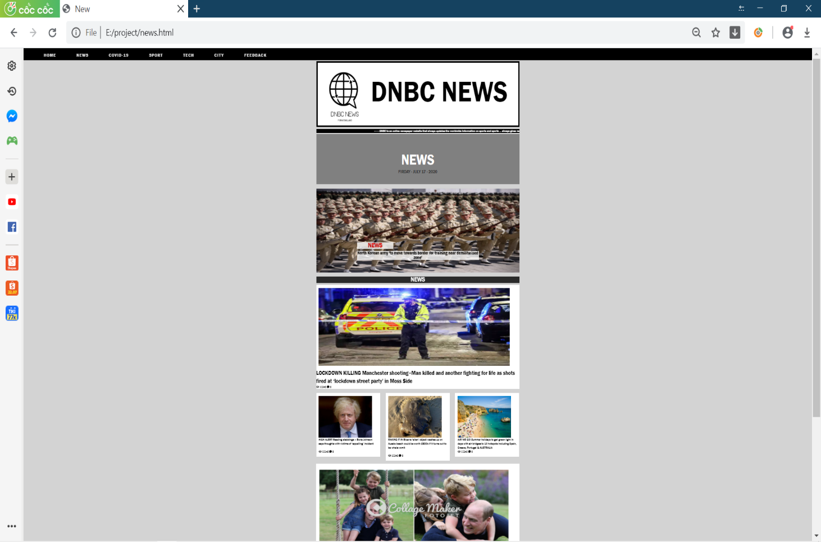

1. **Covid-19 page**

- This page displays news about the covid pandemic and summarizes the cause of the evolution and results of statistical data

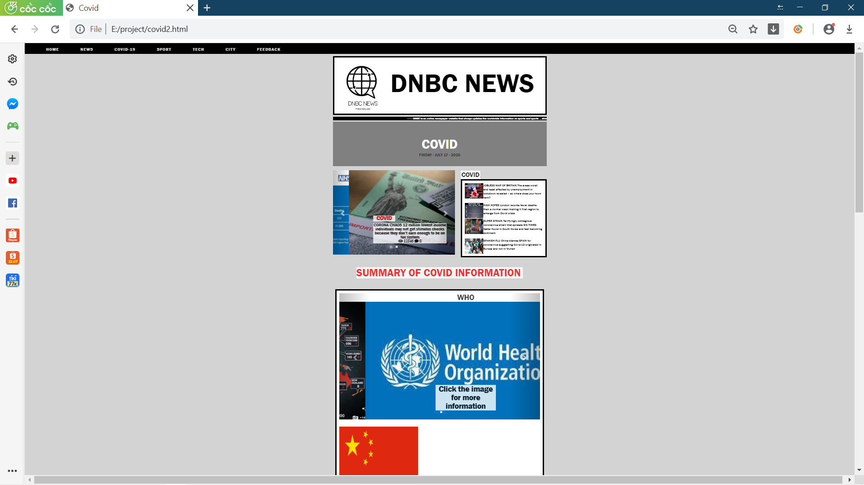

1. **Sport page**

* This page displays sports news about football, boxing, golf, and tennis

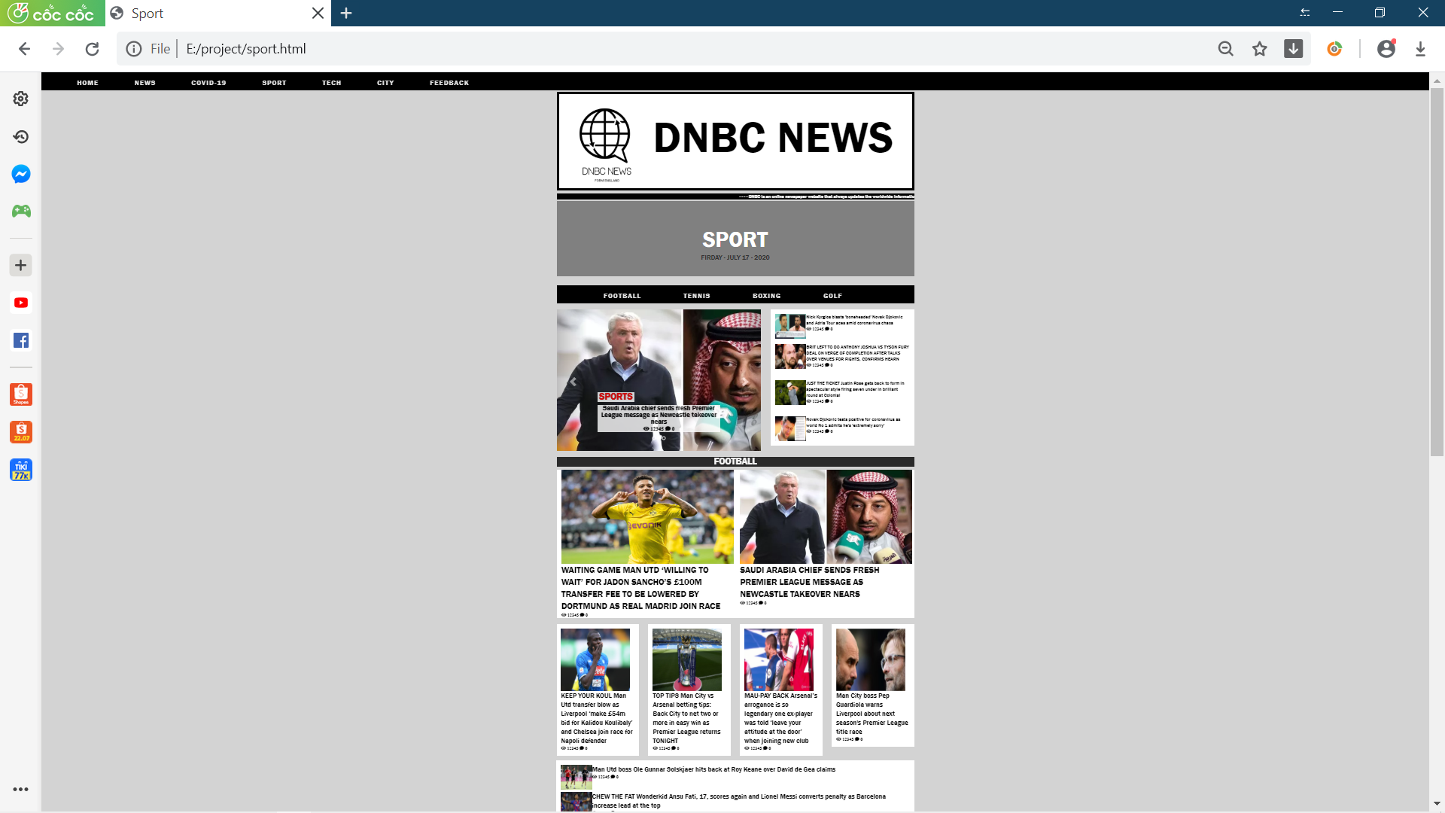

1. **Tech page**

- This page displays technology news

.

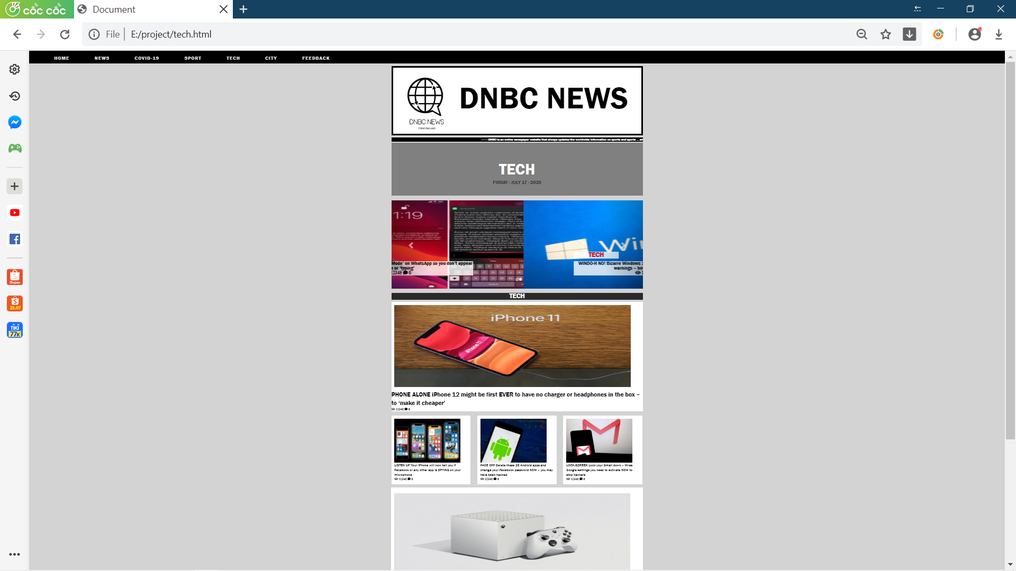

1. **City page**

- This page displays information about 5 cities in the world

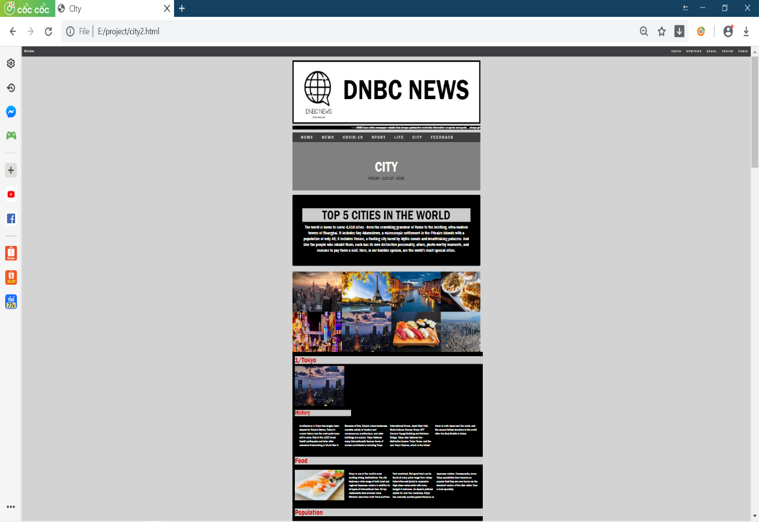

*Figure 11*

1. **Feedback page**

-This page is for readers to note and review the site

